***Earlist Deadline First   
Project***

Calculating CPU Utilization for the following Tasks to Prove Schedulablility:

Now to recalculate using Time Demand Analysis for The 4 main Tasks:  
for (Task 4):  
now tasks (1) and (2) are going to enter:

Now to recalculate using Time Demand Analysis for The 6 Tasks with system load:   
for (Task 5):

for (Task 4):  
now tasks (1) and (2) are going to enter:

Figure (1) shows the Schedulable System, while Figure (2) will show the System is going to be not Schedulable when it comes to Fixed Priority.

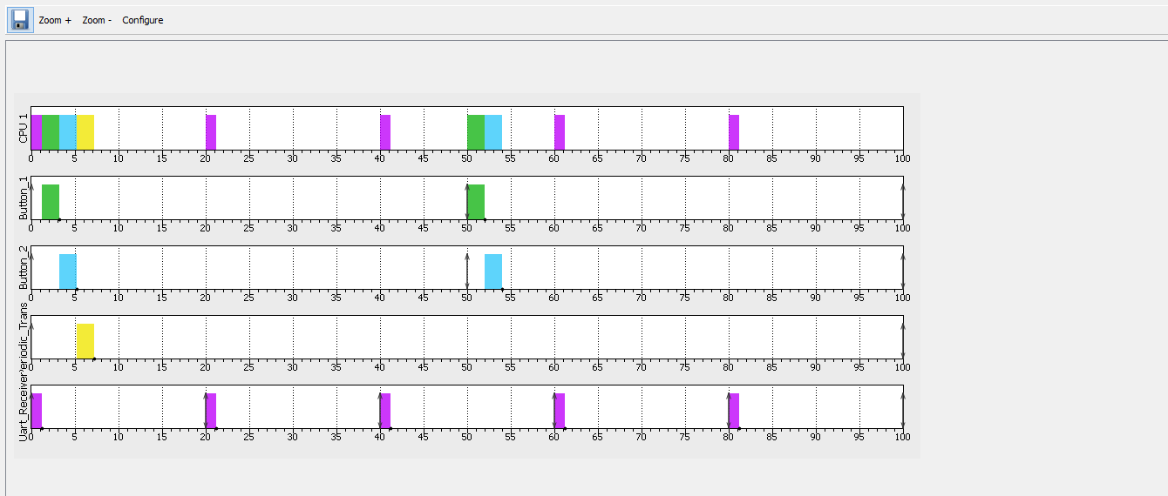

Figure (1) Rate Monotic Schedulablility for the 4 Main Tasks

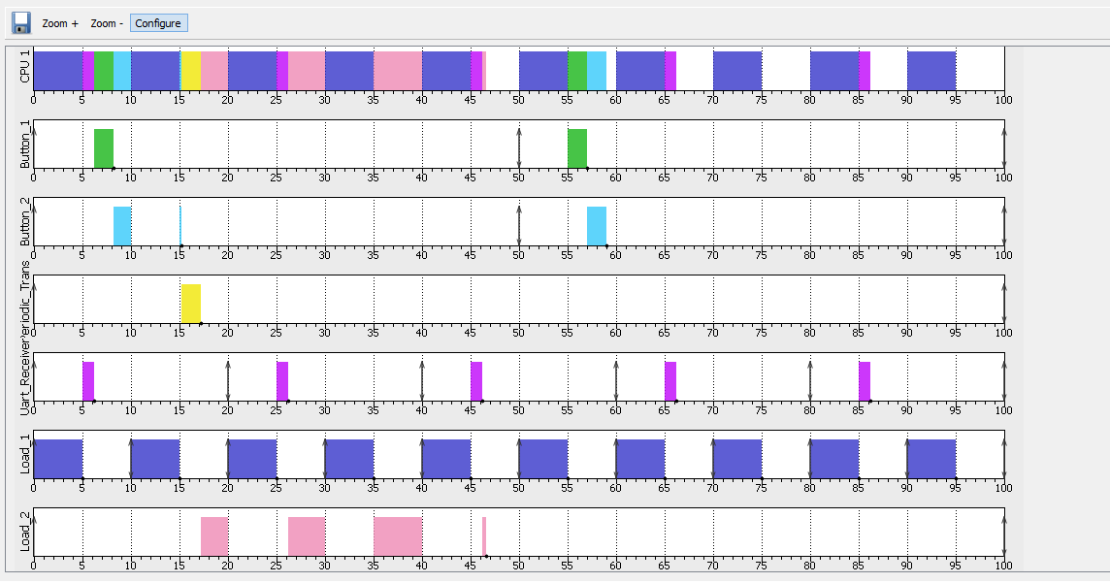

Figure (2) Rate-monotonic with all 6 Tasks added to CPU Load

The Following Figure is showing the Behavior of the system based on Events as follows:

Using Logic Analyzer:

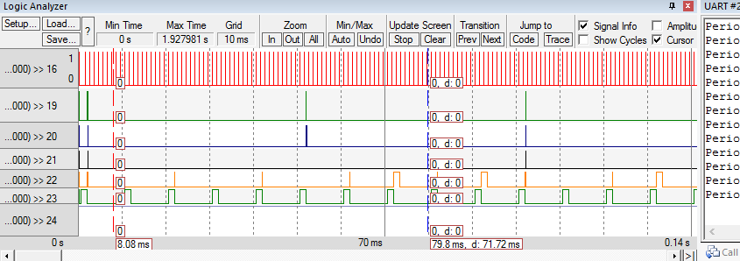

Figure (3) Logic Analyzer showing the behavior of the System with both load Functions sequentially